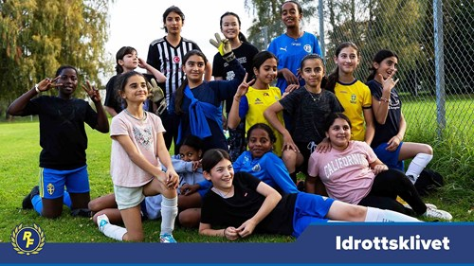
Korpen PowerUp

Korpen PowerUp is an activity for young people aged 13-16 who are not involved in club life and who want to find joy and community in a training group, where we decide together what to do.
We meet 10 Sundays at 10-11 am, in Frödingskolan, start October 5. We finsh the semester with an extra fun activity that we come up with together!
The first semester you pay for only membership in the club, 150 SEK for one year. You can register on site, so just come as you are.
Welcome!
For more information, contact Alen Kusmic, alen.kusmic@gmail.com or call 0768 -269866.

